جامعة المنوفية
كلية الحاسبات والمعلومات
2026-2027
Menofyia University
System Analysis & design Project
second year
2026-2027


No. | Name | Section
1 | Sama Hesham Elsafy | 1
2 | Renad Samy Shalaby | 1
3 | Zeyad Walid Kodeha | 1
4 | Badr Mohamed Serag Elden | 1
5 | Ali Tarek Ali Abdelghane | 2
6

League Fixture Generator System

Planning (Project Plan)

Project Identification
Project Name:
League Fixture Generator System

Current Problem:
- League fixtures are prepared manually on paper or in spreadsheets, which takes hours and is error-prone.
- Scheduling clashes occur frequently, such as booking the same team twice in one round or assigning two matches to the same venue and time slot.
- Maintaining fairness across rounds (balancing home/away matches and ensuring minimum rest days between matches) is difficult by hand.
- Any schedule change (postponed match, withdrawn team, or unavailable pitch) forces the organizer to rebuild subsequent rounds manually, and teams receive inconsistent schedule versions.

Description about project:
- The League Fixture Generator System is a proposed web application designed to automate the creation and management of sports league schedules. The league organizer enters the participating teams, selects the tournament format (single or double round-robin, with automatic bye handling for an odd number of teams and optional knockout support), and specifies available dates, venues, and scheduling constraints. The system automatically generates a conflict-free fixture list arranged by rounds with assigned dates, times, and venues. Organizers can review, edit, and regenerate affected rounds after postponements, export or print a single consistent schedule for all teams, and record match results to display a basic points table (standings). (Note: all figures and scenarios in this report are proposed student-project assumptions to be validated through stakeholder interviews.)
System Request
System Request—League Fixture Generator System
Project Sponsor: | League Organizer / University Sports Committee (proposed sponsor; to be confirmed)
Business Need: | 1- Reduce the time and manual effort required to prepare a season fixture.  2- Eliminate scheduling conflicts (team double-bookings and venue/time clashes).  3- Ensure fair and consistent schedules for all teams (balanced home/away and rest days).  4- Provide teams with instant access to an up-to-date, printable/exportable schedule.
Business Requirements: | 1- Register participating teams, available venues/pitches, and match dates/time slots.  2- Configure league format (single/double round-robin; bye handling; optional knockout) and scheduling constraints.  3- Automatically generate a conflict-free fixture schedule organized by rounds.  4- Allow the organizer to edit, regenerate affected rounds after postponements, and export/print schedules (PDF/spreadsheet).  5- Record match scores and automatically update league standings (lower-priority feature).
Business Value: | 1- Reduce initial fixture preparation time from several hours to a few minutes (target estimate).  2- Achieve zero team or venue double-bookings in generated schedules.  3- Minimize manual rescheduling rework when matches are postponed or venues change.  4- High economic feasibility using free open-source development tools (illustrative annual time/admin savings of $630–$970 vs. $150–$400 first-year setup/hosting costs).
Special Issues or Constraints: | 1- Proposed project delivery within the 60-working-day academic schedule (~12 weeks; exact submission deadline to be confirmed by the course instructor).  2- Schedule quality depends on accurate entry of teams, venue availability, and blackout dates.  3- Specific league rules (minimum rest days, odd-team bye rules, tie-breakers) are treated as working assumptions until confirmed by stakeholder interviews.
Feasibility Analysis
Technical Feasibility
  - The system can be built as a standard web application using HTML, CSS, and JavaScript for the user interface, paired with a server-side backend and a relational database (MySQL/PostgreSQL).
  - The core round-robin pairing algorithm (circle method with automatic bye allocation for odd team counts and conflict-free date/venue assignment) is well-established and suitable for a second-year student team.
  - Free, familiar development tools such as Visual Studio Code, Git, and an open-source database engine are sufficient to develop and test the system.
  - The web interface runs in any standard desktop or mobile browser over the internet or a local demonstration server (complex multi-city travel optimization is out of scope).
Economic Feasibility
  - In-house development by the five-student project team uses free, open-source software, resulting in $0 commercial software licensing cost (illustrative initial setup/utility cost estimated at $0–$100, midpoint $50).
  - Annual operating, hosting, training, maintenance, and administrative transition costs are small for a university/amateur league (illustrative first-year total of $150–$400, midpoint $275; see companion Excel workbook).
  - Quantified annual benefits from avoided scheduling errors, reduced coordination workload, fast postponement updates, and paperless distribution are illustratively estimated at $630–$970 per year (midpoint $800/year), plus intangible user-experience gains.
  - Expected net first-year benefit is +$525 (range $480–$570) with an estimated payback period of ~0.34 years (~4.1 months, within the first semester), confirming that the system is economically feasible.
Organizational Feasibility
Organizational, operational, legal, and schedule feasibility assessment:
- Management support & user acceptance: The league organizer (proposed sponsor) benefits directly from reduced manual workload and zero double-bookings, while team representatives only need a simple view/download interface.
- Resource sufficiency & legal compliance: Five second-year Computer Science students with personal computers and open-source tools are sufficient; the system stores only non-sensitive league data and respects fair-play rules and open-source licenses.
3. Schedule feasibility: The project is planned across 60 working days (~12 weeks) following the Waterfall SDLC (Planning 9d, Analysis 12d, Design 21d, Implementation 18d), which is achievable within the academic calendar.
Methodology
Selected Methodology — Waterfall SDLC: The proposed development methodology is the Waterfall System Development Life Cycle (SDLC), organized into four sequential phases: Planning (15% = 9 working days), Analysis (20% = 12 working days), Design (35% = 21 working days), and Implementation & Testing (30% = 18 working days). Why Waterfall fits this project: (1) the project scope and core fixture-generation rules are well-defined by the course template; (2) each phase produces structured academic deliverables (System Request, Feasibility Study, PERT/Gantt, DFDs, ERD, Design Specification, and working prototype) for instructor review before the next phase begins; and (3) it aligns directly with the standard 15% / 20% / 35% / 30% time estimation split.
SDLC Phase | Share | Duration | Core Activities & Deliverables (Tasks T1–T12)
Planning | 15% | 9 days (Days 1–9) | T1: System Request & Project Identification; T2: Feasibility Study & Cost-Benefit Analysis; T3: Methodology, PERT & Gantt Charts.
Analysis | 20% | 12 days (Days 10–21) | T4: 10 Stakeholder Interview Questions & Interview Report; T5: 10 Google Form Questions; T6: DFDs; T7: Data Store & Dictionary; T8: Process Spec.; T9: ERD; T10: Normalization.
Design | 35% | 21 days (Days 22–42) | T11: Architecture Design, Relational Database Schema, Physical DFD/ERD, and User Interface Prototype.
Implementation | 30% | 18 days (Days 43–60) | T12: Round-Robin Fixture Engine Coding, Data Entry Modules, PDF/Spreadsheet Export, Integration & System Testing.
Case Study (Hypothetical)
Note: This scenario is a hypothetical illustration created to demonstrate the scheduling problem and proposed system workflow; it is not taken from a real client interview.
Current Manual Process & Challenges: A university sports committee organizes an eight-team inter-department football league each semester across two shared campus pitches. Currently, one student coordinator prepares the entire seven-round single round-robin schedule (28 matches) by hand in a spreadsheet. He lists the teams, writes round pairings manually, and cross-checks a paper calendar to assign dates and pitches. Drafting the initial schedule takes several hours; in past semesters, two matches were accidentally booked on the same pitch at the same time, one team was scheduled twice in the same round, and rain postponements forced the coordinator to rebuild later rounds manually and send updated screenshots via chat groups.
How the Proposed System Solves the Problem: Using the proposed League Fixture Generator System, the coordinator enters the eight teams, the two pitches, the available match slots, and the minimum rest-day constraint once. The system automatically generates a conflict-free seven-round schedule in seconds with balanced home/away assignments. After a postponement, the coordinator updates availability, regenerates the affected round without clashes, and exports one consistent PDF/spreadsheet schedule for all teams.
Time Estimation
Total Estimated Project Duration = 60 working days (100%): 9 + 12 + 21 + 18 = 60 working days (based on 9 planning days = 15% of total project time, so 1% = 0.6 working days). All durations are illustrative project estimates.
Phase | Planning | Analysis | Design | Implementation
Standard percentages | 15% | 20% | 35% | 30%
Estimated time based on planning time | 9 working days  (Days 1–9) | 12 working days  (Days 10–21) | 21 working days  (Days 22–42) | 18 working days  (Days 43–60)
Tasks Identification
T1: System Request & Project Identification (Planning Phase) | Name of Task
Day 1 (Relative Working Day; ES = 0) | Start Date
Day 3 (Relative Working Day; EF = 3) | End Date
Sama Hesham Elsafy, Renad Samy Shalaby | Person assigned to task
High (Critical Path: Yes; Predecessors: -) | Priority
Microsoft Word | Resources Needed
3 working days (PERT: O=2d, M=3d, P=4d -> TE=3d; Slack=0d) | Estimated Time
[To be recorded upon task completion] | Actual Time

T2: Feasibility Study & Cost-Benefit Analysis (Planning Phase) | Name of Task
Day 4 (Relative Working Day; ES = 3) | Start Date
Day 6 (Relative Working Day; EF = 6) | End Date
Zeyad Walid Kodeha | Person assigned to task
High (Critical Path: Yes; Predecessors: T1) | Priority
Microsoft Word, Microsoft Excel | Resources Needed
3 working days (PERT: O=2d, M=3d, P=4d -> TE=3d; Slack=0d) | Estimated Time
[To be recorded upon task completion] | Actual Time

T3: Methodology, PERT Chart & Gantt Chart (Planning Phase) | Name of Task
Day 7 (Relative Working Day; ES = 6) | Start Date
Day 9 (Relative Working Day; EF = 9) | End Date
Badr Mohamed Serag Elden, Ali Tarek Ali Abdelghane | Person assigned to task
High (Critical Path: Yes; Predecessors: T2) | Priority
MS Project / Scheduling Tools | Resources Needed
3 working days (PERT: O=2d, M=3d, P=4d -> TE=3d; Slack=0d) | Estimated Time
[To be recorded upon task completion] | Actual Time

T4: Interview (10 Interview Questions & Interview Report) (Analysis Phase) | Name of Task
Day 10 (Relative Working Day; ES = 9) | Start Date
Day 13 (Relative Working Day; EF = 13) | End Date
Sama Hesham Elsafy, Renad Samy Shalaby | Person assigned to task
High (Critical Path: Yes; Predecessors: T3) | Priority
Microsoft Word, Interview Guide | Resources Needed
4 working days (PERT: O=3d, M=4d, P=5d -> TE=4d; Slack=0d) | Estimated Time
[To be recorded upon task completion] | Actual Time

T5: Questionnaire (10 Google Form Questions) (Analysis Phase) | Name of Task
Day 10 (Relative Working Day; ES = 9) | Start Date
Day 12 (Relative Working Day; EF = 12) | End Date
Zeyad Walid Kodeha | Person assigned to task
Medium (Critical Path: No; Predecessors: T3) | Priority
Google Forms | Resources Needed
3 working days (PERT: O=2d, M=3d, P=4d -> TE=3d; Slack=1d) | Estimated Time
[To be recorded upon task completion] | Actual Time

T6: Data Flow Diagrams (Context, Level 0, Level 1) (Analysis Phase) | Name of Task
Day 14 (Relative Working Day; ES = 13) | Start Date
Day 16 (Relative Working Day; EF = 16) | End Date
Badr Mohamed Serag Elden, Ali Tarek Ali Abdelghane | Person assigned to task
High (Critical Path: Yes; Predecessors: T4, T5) | Priority
Draw.io / Visual Paradigm | Resources Needed
3 working days (PERT: O=2d, M=3d, P=4d -> TE=3d; Slack=0d) | Estimated Time
[To be recorded upon task completion] | Actual Time

T7: Data Store & Data Dictionary (Analysis Phase) | Name of Task
Day 17 (Relative Working Day; ES = 16) | Start Date
Day 18 (Relative Working Day; EF = 18) | End Date
Zeyad Walid Kodeha | Person assigned to task
High (Critical Path: Yes; Predecessors: T6) | Priority
Microsoft Word | Resources Needed
2 working days (PERT: O=1d, M=2d, P=3d -> TE=2d; Slack=0d) | Estimated Time
[To be recorded upon task completion] | Actual Time

T8: Process Specification (Analysis Phase) | Name of Task
Day 17 (Relative Working Day; ES = 16) | Start Date
Day 18 (Relative Working Day; EF = 18) | End Date
Sama Hesham Elsafy | Person assigned to task
High (Critical Path: Yes; Predecessors: T6) | Priority
Microsoft Word | Resources Needed
2 working days (PERT: O=1d, M=2d, P=3d -> TE=2d; Slack=0d) | Estimated Time
[To be recorded upon task completion] | Actual Time

T9: Entity Relationship Diagram (ERD) (Analysis Phase) | Name of Task
Day 19 (Relative Working Day; ES = 18) | Start Date
Day 21 (Relative Working Day; EF = 21) | End Date
Renad Samy Shalaby | Person assigned to task
High (Critical Path: Yes; Predecessors: T7, T8) | Priority
StarUML / Draw.io | Resources Needed
3 working days (PERT: O=2d, M=3d, P=4d -> TE=3d; Slack=0d) | Estimated Time
[To be recorded upon task completion] | Actual Time

T10: Normalization (1NF, 2NF, 3NF) (Analysis Phase) | Name of Task
Day 19 (Relative Working Day; ES = 18) | Start Date
Day 20 (Relative Working Day; EF = 20) | End Date
Ali Tarek Ali Abdelghane | Person assigned to task
High (Critical Path: No; Predecessors: T7, T8) | Priority
Microsoft Word, Schema Tools | Resources Needed
2 working days (PERT: O=1d, M=2d, P=3d -> TE=2d; Slack=1d) | Estimated Time
[To be recorded upon task completion] | Actual Time

T11: System Design (Architecture, Database & UI Prototype) (Design Phase) | Name of Task
Day 22 (Relative Working Day; ES = 21) | Start Date
Day 42 (Relative Working Day; EF = 42) | End Date
All 5 Team Members | Person assigned to task
High (Critical Path: Yes; Predecessors: T9, T10) | Priority
Visual Studio Code, Figma, MySQL | Resources Needed
21 working days (PERT: O=18d, M=21d, P=24d -> TE=21d; Slack=0d) | Estimated Time
[To be recorded upon task completion] | Actual Time

T12: Implementation, Fixture Engine & Testing (Implementation Phase) | Name of Task
Day 43 (Relative Working Day; ES = 42) | Start Date
Day 60 (Relative Working Day; EF = 60) | End Date
All 5 Team Members | Person assigned to task
High (Critical Path: Yes; Predecessors: T11) | Priority
Visual Studio Code, HTML/CSS/JS, DB | Resources Needed
18 working days (PERT: O=15d, M=18d, P=21d -> TE=18d; Slack=0d) | Estimated Time
[To be recorded upon task completion] | Actual Time

Pert Chart (MS-Project)
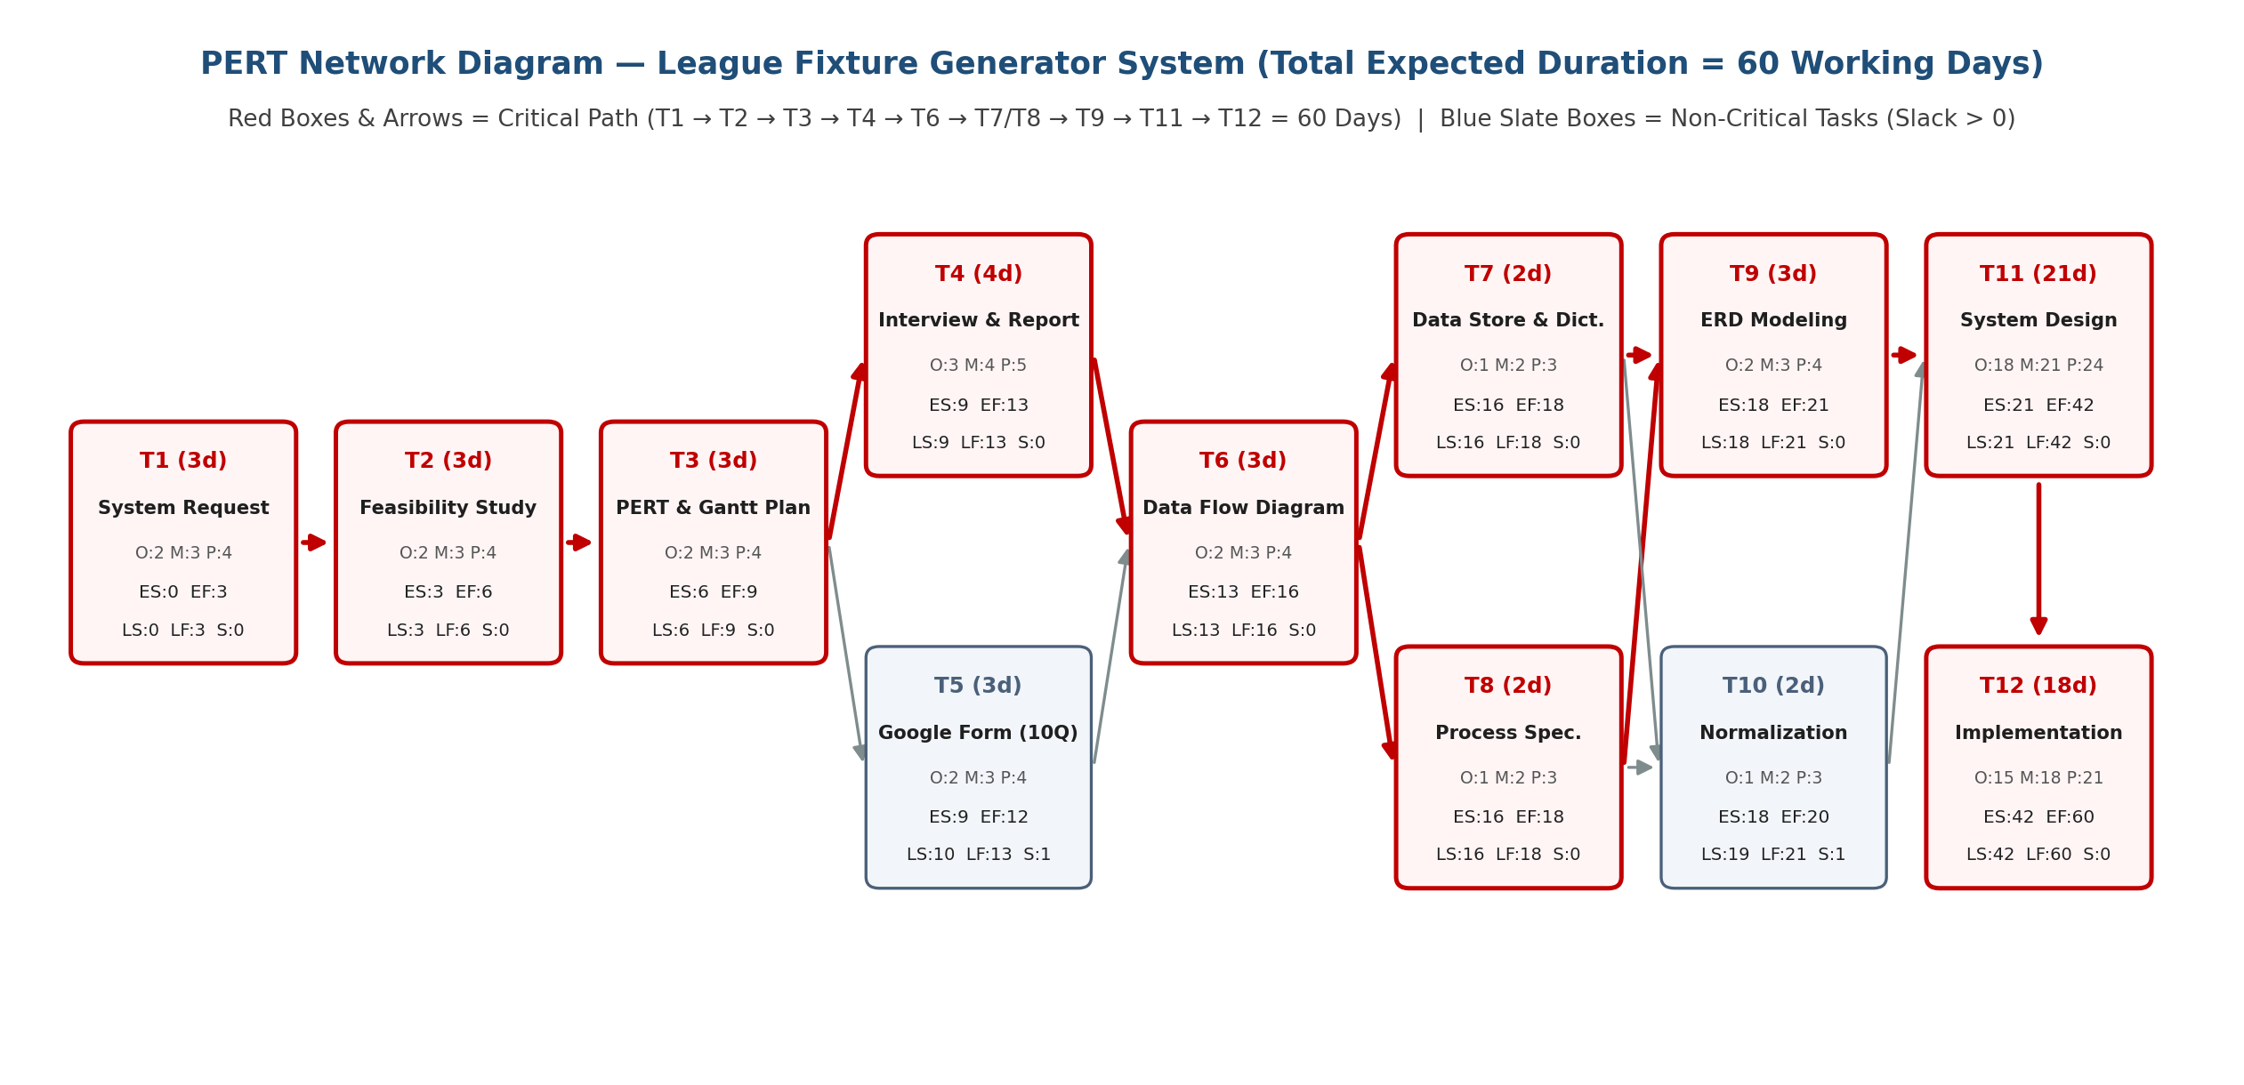
PERT Expected Duration Formula: TE = (Optimistic + 4 × Most Likely + Pessimistic) / 6. Critical Path: T1 → T2 → T3 → T4 → T6 → T7/T8 → T9 → T11 → T12 = 3 + 3 + 3 + 4 + 3 + 2 + 3 + 21 + 18 = 60 working days.
ID | Task Name | Pred. | O / M / P (d) | TE | ES–EF | LS–LF | Slack | Critical
T1 | System Request & Project Identification | - | 2 / 3 / 4 | 3d | 0–3 | 0–3 | 0d | Yes
T2 | Feasibility Study & Cost-Benefit Analysis | T1 | 2 / 3 / 4 | 3d | 3–6 | 3–6 | 0d | Yes
T3 | Methodology, PERT Chart & Gantt Chart | T2 | 2 / 3 / 4 | 3d | 6–9 | 6–9 | 0d | Yes
T4 | Interview (10 Interview Questions & Interview Report) | T3 | 3 / 4 / 5 | 4d | 9–13 | 9–13 | 0d | Yes
T5 | Questionnaire (10 Google Form Questions) | T3 | 2 / 3 / 4 | 3d | 9–12 | 10–13 | 1d | No
T6 | Data Flow Diagrams (Context, Level 0, Level 1) | T4, T5 | 2 / 3 / 4 | 3d | 13–16 | 13–16 | 0d | Yes
T7 | Data Store & Data Dictionary | T6 | 1 / 2 / 3 | 2d | 16–18 | 16–18 | 0d | Yes
T8 | Process Specification | T6 | 1 / 2 / 3 | 2d | 16–18 | 16–18 | 0d | Yes
T9 | Entity Relationship Diagram (ERD) | T7, T8 | 2 / 3 / 4 | 3d | 18–21 | 18–21 | 0d | Yes
T10 | Normalization (1NF, 2NF, 3NF) | T7, T8 | 1 / 2 / 3 | 2d | 18–20 | 19–21 | 1d | No
T11 | System Design (Architecture, Database & UI Prototype) | T9, T10 | 18 / 21 / 24 | 21d | 21–42 | 21–42 | 0d | Yes
T12 | Implementation, Fixture Engine & Testing | T11 | 15 / 18 / 21 | 18d | 42–60 | 42–60 | 0d | Yes
Gantt chart (MS-Project)
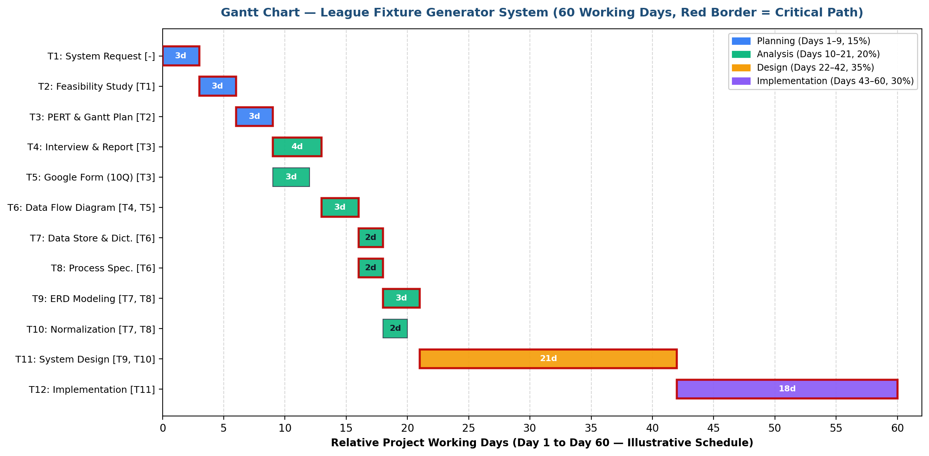
Gantt Schedule Summary: Relative working days (Day 1 to Day 60) matching the PERT network and Time Estimation table.
ID | Task Name | SDLC Phase | Pred. | Start – End | Duration | Assigned Team Member(s)
T1 | System Request & Project Identification | Planning | - | Day 1 – Day 3 | 3 days | Sama Hesham Elsafy, Renad Samy Shalaby
T2 | Feasibility Study & Cost-Benefit Analysis | Planning | T1 | Day 4 – Day 6 | 3 days | Zeyad Walid Kodeha
T3 | Methodology, PERT Chart & Gantt Chart | Planning | T2 | Day 7 – Day 9 | 3 days | Badr Mohamed Serag Elden, Ali Tarek Ali Abdelghane
T4 | Interview (10 Interview Questions & Interview Report) | Analysis | T3 | Day 10 – Day 13 | 4 days | Sama Hesham Elsafy, Renad Samy Shalaby
T5 | Questionnaire (10 Google Form Questions) | Analysis | T3 | Day 10 – Day 12 | 3 days | Zeyad Walid Kodeha
T6 | Data Flow Diagrams (Context, Level 0, Level 1) | Analysis | T4, T5 | Day 14 – Day 16 | 3 days | Badr Mohamed Serag Elden, Ali Tarek Ali Abdelghane
T7 | Data Store & Data Dictionary | Analysis | T6 | Day 17 – Day 18 | 2 days | Zeyad Walid Kodeha
T8 | Process Specification | Analysis | T6 | Day 17 – Day 18 | 2 days | Sama Hesham Elsafy
T9 | Entity Relationship Diagram (ERD) | Analysis | T7, T8 | Day 19 – Day 21 | 3 days | Renad Samy Shalaby
T10 | Normalization (1NF, 2NF, 3NF) | Analysis | T7, T8 | Day 19 – Day 20 | 2 days | Ali Tarek Ali Abdelghane
T11 | System Design (Architecture, Database & UI Prototype) | Design | T9, T10 | Day 22 – Day 42 | 21 days | All 5 Team Members
T12 | Implementation, Fixture Engine & Testing | Implementation | T11 | Day 43 – Day 60 | 18 days | All 5 Team Members

Analysis (Project Proposal)

Interview (10 Interview Questions)
No. | Question Type | Interview Question (Verbal Stakeholder Interview) | Sample / Assumed Response (To Be Replaced After Actual Interview)
1 | Open-ended | Can you walk us through how you currently prepare the league fixture schedule from the moment team registration closes until the final schedule is shared? | Sample / Assumed Response: Fixtures are prepared manually using paper notes and a spreadsheet by pairing teams round by round and checking a calendar for free pitch dates.
2 | Open-ended | What are the most common scheduling errors or conflicts you encounter when building the fixture list manually? | Sample / Assumed Response: Accidental double-booking of two matches at the same venue and time, scheduling the same team twice in one round, and uneven rest periods between matches.
3 | Closed-ended (Yes / No) | Do multiple participating teams share the same stadium or pitch during the league season? (Yes / No — if Yes, how many pitches are typically shared?) | Sample / Assumed Response: Yes; typically 1 to 2 shared university or club pitches host all league matches, so only one match can be played per pitch at any given time slot.
4 | Open-ended | When a match is postponed due to weather or venue unavailability, how do you currently update the schedule and notify the affected teams? | Sample / Assumed Response: Later rounds are edited by hand in the spreadsheet to avoid new clashes, and updated screenshots are sent to team captains via messaging groups.
5 | Closed-ended (Yes / No) | Does your league ever include an odd number of teams that requires one team to receive a rest (bye) in each round? (Yes / No) | Sample / Assumed Response: Yes; when an odd number of teams registers, one team must be assigned a bye each round so every team rests once per cycle.
6 | Open-ended | Which fairness rules—such as balancing home and away assignments or enforcing a minimum number of rest days between matches—are hardest to maintain by hand? | Sample / Assumed Response: Tracking minimum rest days across consecutive weeks and keeping home/away counts balanced across all rounds is very difficult to verify manually.
7 | Open-ended | What should the proposed League Fixture Generator System do if the entered dates, venues, and rest-day constraints cannot all be satisfied at the same time? | Sample / Assumed Response: The system should display a clear conflict warning identifying which specific constraint (date, pitch slot, or rest period) failed so the organizer can adjust it.
8 | Closed-ended (Fixed Choice: Organizer Only / Organizer & Assistants / Team Representatives) | Who should have permission to generate, edit, or regenerate the official league fixture schedule in the new system? | Sample / Assumed Response: Organizer Only (or an authorized Fixture Planner); team representatives and players should have view-only and download access.
9 | Closed-ended (Yes / No) | In addition to generating schedules, should the system also allow recording match scores and displaying an updated league standings table? (Yes / No) | Sample / Assumed Response: Yes, as a secondary feature to keep the official schedule, match results, and points table in one place.
10 | Open-ended | What key improvements or outcomes would make you consider the new League Fixture Generator System a success for your league? | Sample / Assumed Response: Generating a conflict-free season schedule in minutes, handling postponements without manual errors, and exporting one consistent printable PDF or spreadsheet for all teams.
Interview Reports
Interview Report — League Fixture Generator System
Target Interviewee Role: League Organizer / Fixture Planner [Complete using the actual interview responses]
Interviewer(s): Project Team (Sama Hesham Elsafy, Renad Samy Shalaby, Zeyad Walid Kodeha, Badr Mohamed Serag Elden, Ali Tarek Ali Abdelghane)
Note on Findings: No live interview has been conducted yet; placeholders and labelled sample/hypothetical analysis are provided below.
1. Interview Opinion
[Complete using the actual interview responses: summarize the interviewee's stated views about the current scheduling process and the proposed system.]
Sample / Hypothetical Analysis (Assumption): The league organizer views manual spreadsheet scheduling as slow, repetitive, and error-prone when checking shared venues across rounds, and strongly supports the proposed system for automating conflict-free round-robin pairings and PDF/spreadsheet exports.
2. Interview Feelings
[Complete using the actual interview responses: summarize the interviewee's expressed concerns, frustrations, confidence, or expectations about the current process and the proposed system.]
Sample / Hypothetical Analysis (Assumption): The organizer feels frustrated when match postponements force manual round rebuilds or when teams complain about clashes and uneven rest days, and feels relieved and optimistic about automated conflict detection provided the interface stays simple and editable.
3. Current State of the System
Based on the project case study and system analysis assumptions (to be verified during the actual interview):
• Fixture Preparation: League schedules are prepared manually on paper or in general-purpose spreadsheets by pairing teams round by round.
• Venue & Date Checking: Shared pitches and available time slots are checked by hand against a calendar, leading to occasional team or venue double-bookings.
• Fairness & Constraints: Balancing home/away assignments, handling odd-team byes, and maintaining minimum rest days between matches are difficult to enforce consistently by hand.
• Updates & Distribution: Any postponement or team withdrawal requires manual re-editing of subsequent rounds; schedules are shared as screenshots or paper handouts, causing version confusion while scores and standings are tracked separately.
4. System Goals
In response to the problems and stakeholder needs identified above, the proposed League Fixture Generator System aims to:
• Automatically generate complete, conflict-free league fixtures (single or double round-robin, with automatic bye handling for odd team counts) from the entered teams, venues, dates, and scheduling constraints.
• Eliminate team double-bookings and venue/time clashes while reducing initial schedule preparation time from hours to minutes.
• Enforce fair scheduling across rounds by balancing home/away assignments and respecting configurable minimum rest days between matches.
• Allow the organizer to review, manually adjust, or quickly regenerate affected rounds after match postponements or venue changes.
• Publish a single, consistent schedule accessible in any web browser and exportable as a printable PDF or spreadsheet for all participating teams.
• Provide basic match score recording and automatic standings (points table) calculation as a secondary feature.
Questionnaire & RESPONSES (10 Google Form Questions)
https://docs.google.com/forms/d/e/1FAIpQLSci18B7nxleDYytFmVqiOPVHcn-aKwh3ZhM8Nkvm6XrcuO5_g/viewform?usp=publish-editor
No. | Question Type | Google Form Question | Response Options / Format
1 | Multiple choice | What is your primary role in the sports league? | • League Organizer  • Fixture Planner  • Venue Coordinator  • Team Representative / Coach  • Player  • Other
2 | Multiple choice | How many teams typically participate in your league season? | • 4–8 teams  • 9–12 teams  • 13–16 teams  • More than 16 teams
3 | Multiple choice | How is your league fixture schedule currently prepared? | • Paper and pen  • Spreadsheet (Microsoft Excel / Google Sheets)  • General calendar application  • Dedicated scheduling software  • Other
4 | Multiple choice | Which league format do you use most often? | • Single round-robin (each team plays every other team once)  • Double round-robin (home and away)  • Group stage followed by knockout  • Knockout only
5 | Multiple choice (Checkboxes — select all that apply) | Which scheduling problems have you experienced in past seasons? | • Same team scheduled twice in one round  • Two matches booked at the same venue and time  • Unfair home/away match balance  • Insufficient rest days between matches  • Delays when rebuilding the schedule after a postponement  • None of the above
6 | Multiple choice | Approximately how long does it currently take to prepare and verify the initial season fixture? | • Less than 1 hour  • 1–3 hours  • 4–6 hours  • More than 6 hours  • Not sure
7 | Closed-ended (Yes / No) | Would automatic conflict detection (preventing team double-bookings and venue clashes) be useful in your league scheduling? | • Yes  • No
8 | Closed-ended (Yes / No) | Should the system enforce a minimum number of rest days between two consecutive matches for the same team? | • Yes  • No
9 | Multiple choice | Which format would you prefer for viewing and sharing the finalized league fixture? | • Printable PDF document  • Editable Excel / CSV spreadsheet  • On-screen web browser view (desktop & mobile)  • All of the above
10 | Open-ended (Short / Paragraph text) | What additional scheduling constraints, views, or features would you like the League Fixture Generator System to include? | [Free-text response field for participant suggestions]

